LinkedIn Crawler Documentation

1. **Introduction**

The linkedin crawler is a web-based application intended to extract information from the linkedin database. The application performs normal linkedin search but outputs the result in an organized way (i.e. in .csv file).

The app also connects you with the Salesforce database. Many features which are particular to salesforce.com have been incorporated in the crawler. A few of these features include getting all contacts and accounts from the salesforce database, checking data with entries all ready present in the salesforce database.

1. **Quick start**
   1. **Login**

The login page looks something like this:

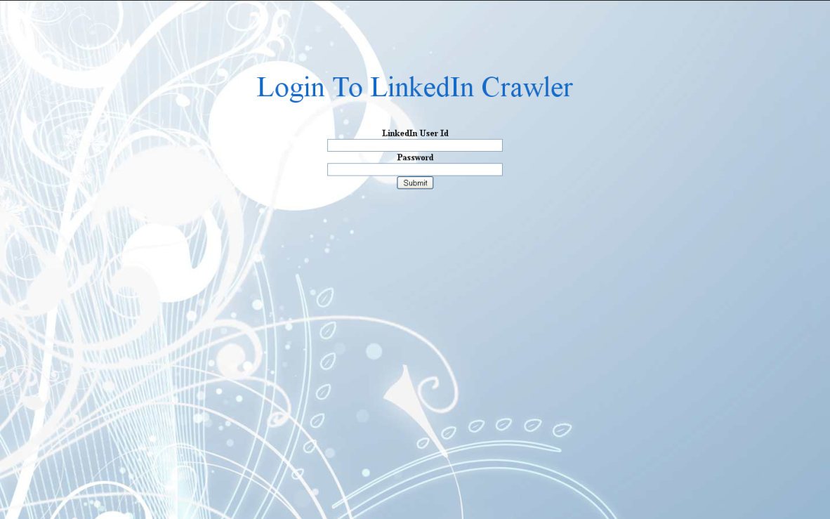

In the ‘LinkedIn User Id’ field you must enter the complete user id that you use to login to [www.linkedin.com](http://www.linkedin.com).

In the password field enter your linkedin password.

**Note: even if you provide the wrong email id and wrong password you will be able to login to the crawler but an error will come if you try to use the search. This is because it checks the email id and password only at the time of submission of search form.**

* 1. **Search**

After entering the emailed and password on the login page the search page is displayed. A message comes at the top right corner displaying your user id. The search page consists of a form which is very similar to the form that you will find on the linkedin search page. There is new field ‘File Name’ in which you need to enter the name of the file in which you want to save the data that we get from linkedin.

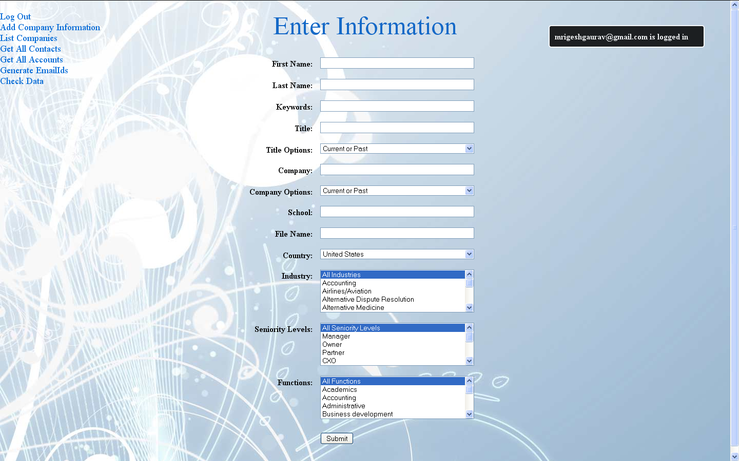

The file name should be a valid file name that windows can save and recognize. (i.e. it should not contain invalid characters such as ‘.’ ’$’ etc) Eg: “searchresult”.

**Note: You must not enter the format of the file as it is automatically appended in the code. The output file will be a .csv file.**

Filled form will look like this:

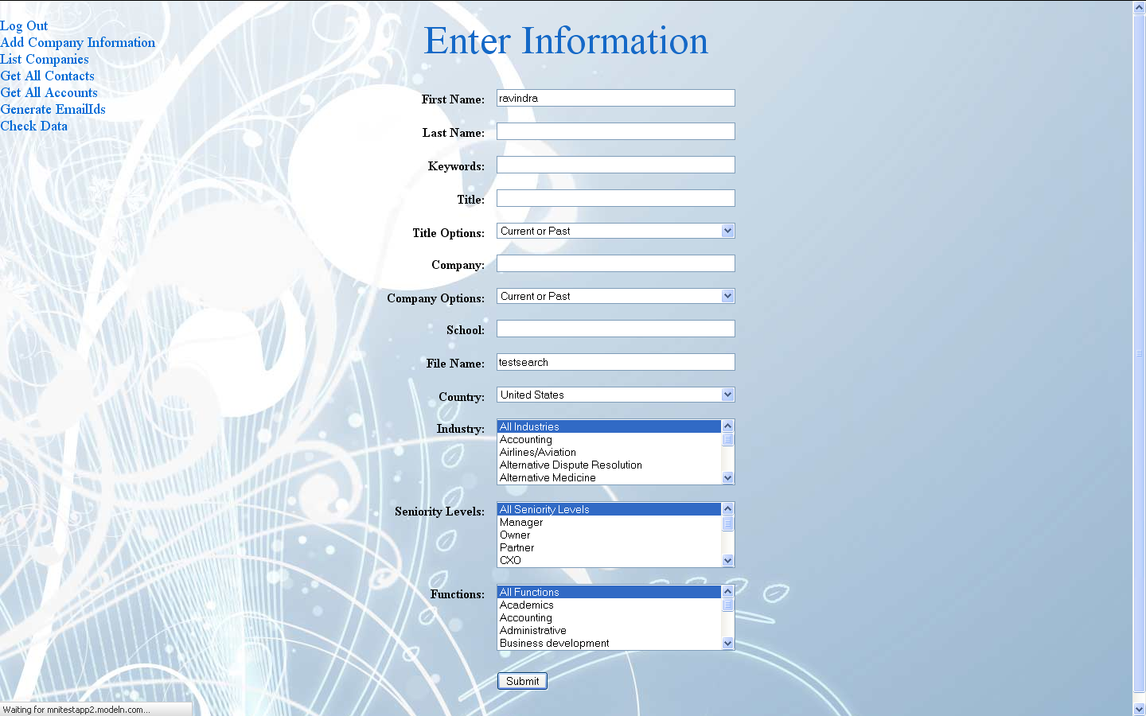

After you submit the form the crawler will login to linkedin using the userid and password you have provided and perform the search. After the search is complete it saves a file on your local system, with the name you provided, containing the data from linkedin.

The file is saved in your downloads folder.

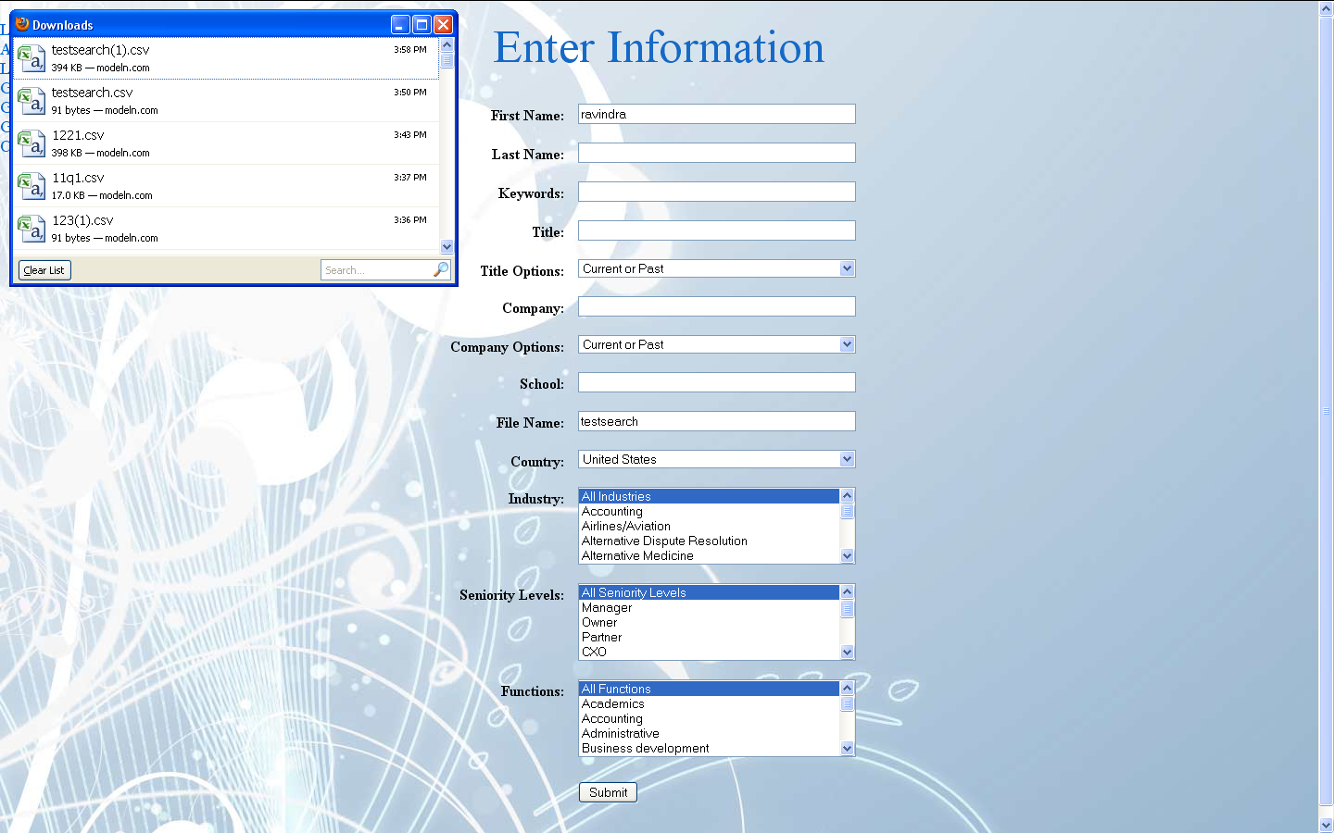

Sample output file:

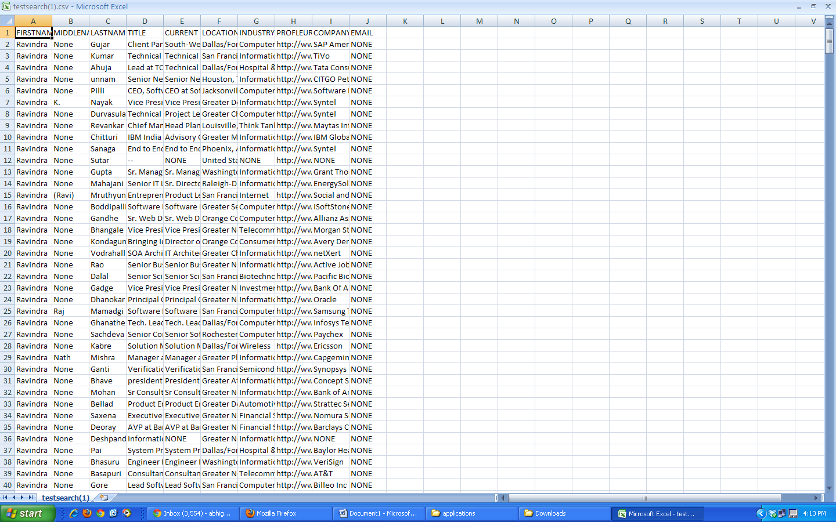

* 1. **Add Company Information**

You must have noticed that in the output file there is a field ‘EMAIL’. But linkedin doesn’t provide any emailid’s.

So where does this field come from??

Actually the app creates this field by using the ‘COMPANYNAME’, ‘FIRSTNAME’ and ‘LASTNAME’ fields.

The app keeps a database for company information. This database basically contains the rules for generating email id’s for the employees of various companies.

For eg: firstname: ravi

lastname: kumar

companyname: merck

Rule: first letter of firstname (‘f’) + delimiter(‘.’) + lastname + ‘@’+domain name

Output Email: [r.kumar@merck.com](mailto:r.kumar@merck.com)

You can add rules in the database using following form.

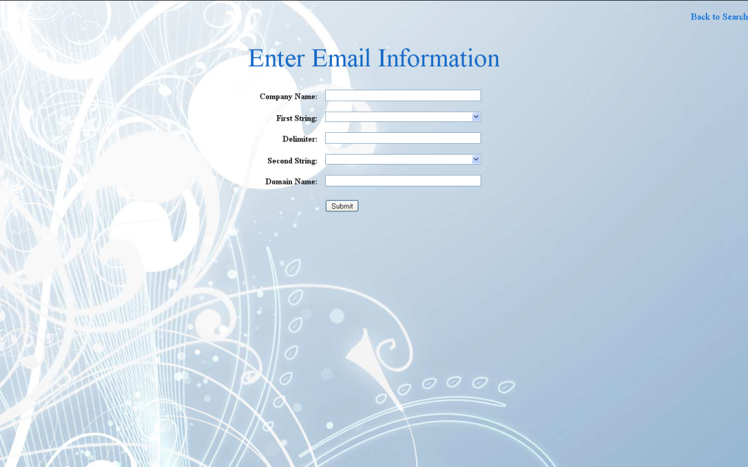

Clicking on list companies link will give you list of the companies.

